Title of The Research (14 Pts, may not use the letters all caps)

Author^{1*}, Author², Author³, Author⁴, Author⁵
^{1,2,3}Affiliation, Country, ⁴Affiliation, Country, ⁵Affiliation, Country
¹email@email.com, ²email@email.com, ³email@email.com, ⁴email@email.com, ⁵email@email.com

Article History:  Submitted: xx  Accepted: xx  Published: xx | ABSTRACT  Abstracts are written in one paragraph consisting of 200 to 250 words. The abstract is a general summary of all scientific writings. The abstract must contain key elements that will be presented briefly. The back ground describes the most recent research you have done or some things you would like to know. You need to put forward the research objective to find out or confirm something. The practical implications of your research results cfgan also be noted (if any). The way you find answers or solve problems can be written in research methods. In the research results section, you can present the findings that you made in your research. Finally, you can write down the conclusions of your research, whether your research is what you expected, or if further research is needed

Keywords:

component; formatting; style; styling; insert (minimum 3 words)
IJNE: International Journal of Comprehensive Research is licensed under a Creative Commons Attribution-NonCommercial 4.0 International (CC BY-NC 4.0).

INTRODUCTION
This template provides authors with most of the formatting specifications needed for preparing electronic versions of their papers for Brilliance: Research of Artificial Intelligence.
The main sections (headings) include Introduction, Literature Review, Methods, Result, Discussion, and Conclusion. In the introduction, researchers are expected to be able to explain the existing phenomena or background information such as prior work, hypotheses, problems are to be discussed. This is followed by a statement of the purpose of the research issue or problem and/or set of questions you attempt to answer in your research.

METHOD
In this section, each researcher is expected to be able to make the most recent contribution related to the solution to the existing problems. Researchers can also use images, diagrams, and flowcharts to explain the solutions to these problems.

RESULT
In this section, the researcher will explain the results of the research obtained. Researchers can also use images, tables, and curves to explain the results of the study. These results should present the raw data or the results after applying the techniques outlined in the methods section. The results are simply results; they do not conclude.

DISCUSSION
In this section, the researchers can give a simple discussion related to the results of the research trials. This section contains the author's opinion about the research results obtained. Common features of the discussion section include the comparison between measured and modeled data or comparison among various modeling methods, the results obtained to solve a specific engineering or scientific problem, and further explanation of new and significant findings

Figure
All figures should be numbered with Arabic numerals (1,2,3,….). Every figure should have a caption in the below of the figure. All photographs, schemas, graphs, and diagrams are to be referred to as figures. Line drawings should be good quality scans or true electronic output. Low-quality scans or monitor capture are not acceptable. Figures must be embedded in the text and not supplied separately. In MS word input the figures must be properly coded. The preferred format of figures is PNG and JPEG. Lettering and symbols should be clearly defined either in the caption or in a legend provided as part of the figure. Figures should be placed at the t op or bottom of a page wherever possible, as close as possible to the first reference to them in the paper. Please ensure that all the figures are of 300 DPI resolutions as this will facilitate good output.
The figure number and caption should be typed below the illustration and left-justified [Note: one-line captions of length less than the column width (or full typesetting width or oblong) centered]. The artwork has no text along the side of it in the main body of the text. However, if two images fit next to each other, these may be placed next to each other to save space. For example, see Fig. 1.
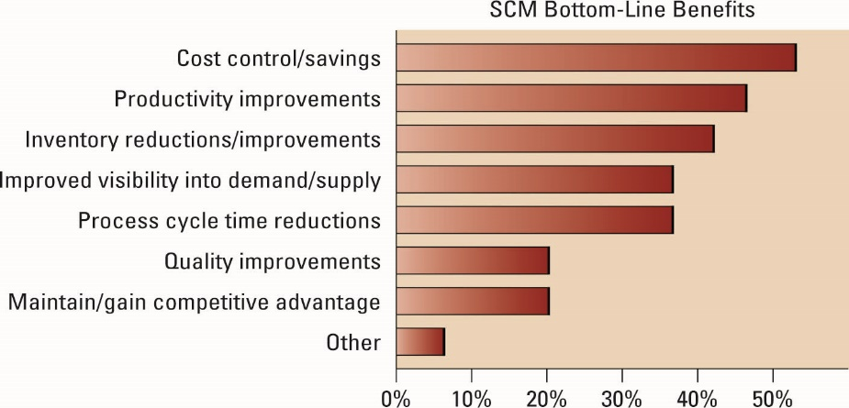
Fig. 1 Caption for figure Times New Roman 10 pt

Table
All tables should be numbered with Arabic numerals. Every table should have a caption. Headings should be placed above tables, left-justified. Only horizontal lines should be used within a table, to distinguish the column headings from the body of the table, and immediately above and below the table. Tables must be embedded in the text and not supplied separately. Table 1 is an example which the authors may find useful.

Table 1
The Significance of The Relationship in The Model
Relationships | Original Sample (O) | Sample Mean (M) | Standard Deviation (STDEV) | T Statistics (|O/STDEV|) | P Values*
Perceive Ease of Use ->Attitude | 0,286 | 0,288 | 0,058 | 4,907 | 0,000
Information Quality ->Intention to Use | 0,175 | 0,174 | 0,072 | 2,434 | 0,015
Information Quality ->User Satisfaction | 0,299 | 0,294 | 0,076 | 3,924 | 0,000
Intention to Use ->Use | 0,657 | 0,658 | 0,039 | 17,054 | 0,000
Use ->Net Benefits | 0,463 | 0,461 | 0,061 | 7,576 | 0,000
Use ->User Satisfaction | 0,405 | 0,400 | 0,068 | 5,936 | 0,000
Perceive Usefulness ->Attitude | 0,455 | 0,455 | 0,056 | 8,058 | 0,000
Performance Expectancy -> Intention to Use | 0,052 | 0,053 | 0,058 | 0,893 | 0,372
Service Quality -> Intention to Use | 0,065 | 0,068 | 0,072 | 0,905 | 0,366
Service Quality ->User Satisfaction | 0,167 | 0,177 | 0,068 | 2,474 | 0,013
Social Influence ->Intention to Use | 0,263 | 0,263 | 0,061 | 4,302 | 0,000
System Quality -> Intention to Use | -0,008 | -0,005 | 0,076 | 0,107 | 0,915
System Quality -> User Satisfaction | 0,065 | 0,066 | 0,072 | 0,904 | 0,366
Attitude ->Intention to Use | 0,337 | 0,331 | 0,075 | 4,488 | 0,000
User Satisfaction ->Net Benefits | 0,428 | 0,430 | 0,059 | 7,207 | 0,000

Equations
Equations and formulae should be typed in Mathtype or any Equation Editor and numbered consecutively with Arabic numerals in parentheses on the right-hand side of the page (if referred to explicitly in the text). They should also be separated from the surrounding text by one space.
Be sure that the symbols in your equation have been defined before or immediately following the equation. Use “(1),” not “Eq. (1)” or “equation (1),” except at the beginning of a sentence: “Equation (1) is ...”

$A=πr^{2}$ (1)

CONCLUSION
The conclusion contains a summary of what is learned from the results obtained, what needs to be improved in further study. Other common features of the conclusions are the benefits and applications of the research, limitation, and recommendations based on the results obtained.

ACKNOWLEDGMENT (optional)
The acknowledgments are given at the end of the research paper and should at a minimum name the sources of funding that contributed to the article. You may also recognize other people who contributed to the article or data contained in the article but at a level of effort that does not justify their inclusion as authors. You may also state the research grant contract number if any.

REFERENCES
References must have 10 minimal sources and the citation and references uses APA 6Th Edition formatting style. The formatting style for citation and references can be seen as the following example (Khairina & Harahap, 2020) :
Khairina, N., & Harahap, M. K. (2018). Menjaga Kerahasiaan Data dengan Steganografi Kombinasi LSB-2 dengan LSB-3. SinkrOn - Jurnal & Penelitian Teknik Informatika , 3(1), 286-288.
Khairina, N., Harahap, M. K., & Lubis, J. H. (2018). The Authenticity of Image using Hash MD5 and Steganography Least Significant Bit . International Journal Of Information System & Technology, 2(1), 1-6.

